Jenkins Assignment 10 using pipeline
There is one github repository project which name LoginWebApp so you build that project into jenkinsa master and deploy on slave using pipeline .
Step -1 - Lauch instance and install java 21 then , create 2 directory like build-tool,server inside mnt
Then goto build tool and wget maven and do set up environment
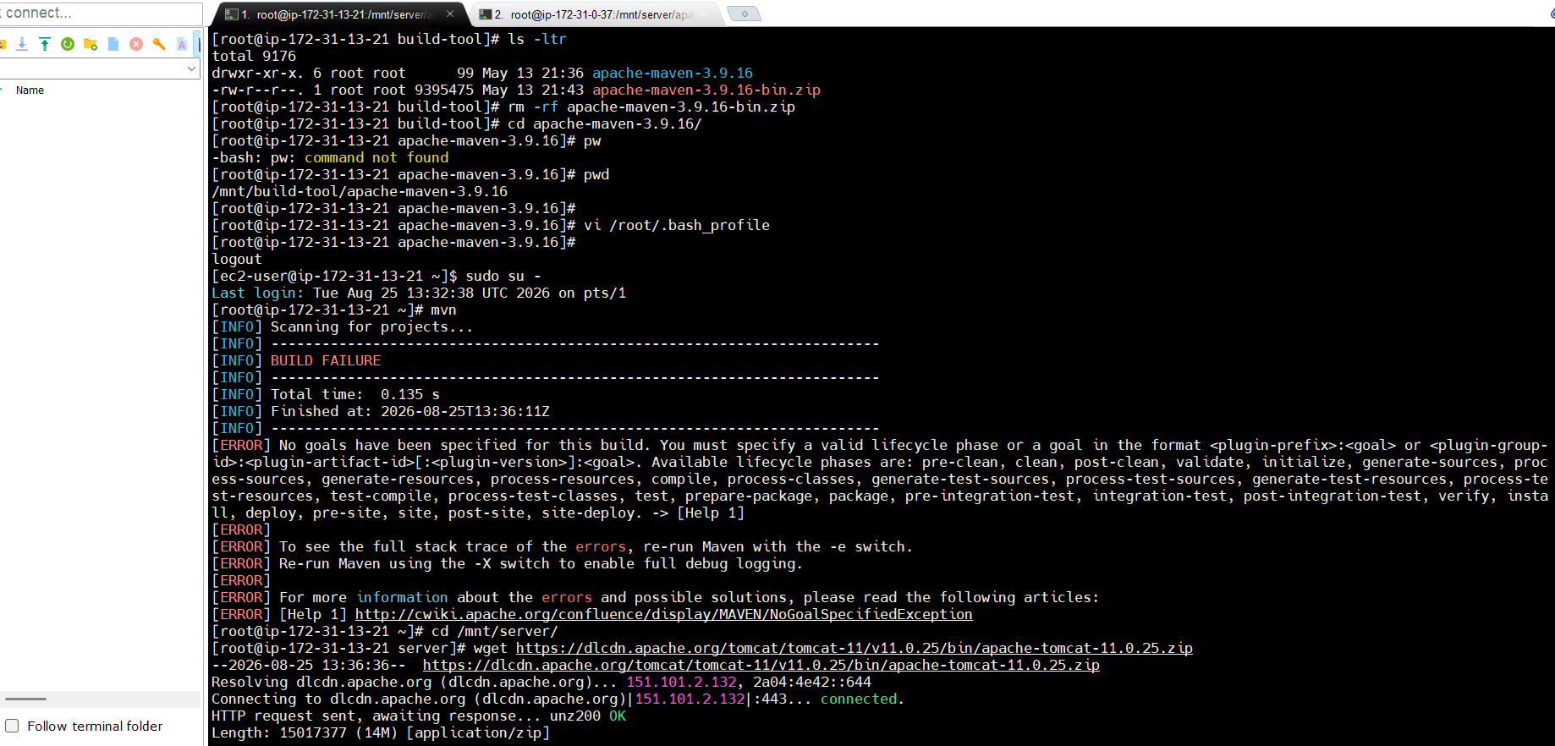
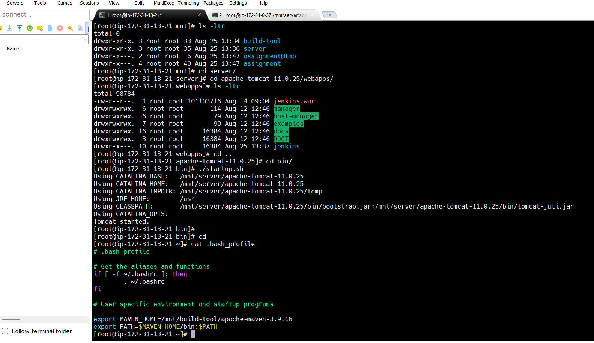
Step 2 – goto server directory and wget tomcat 11 then unzip and give permission then goto bin and do ./startup.sh then goto webapps and wget Jenkins
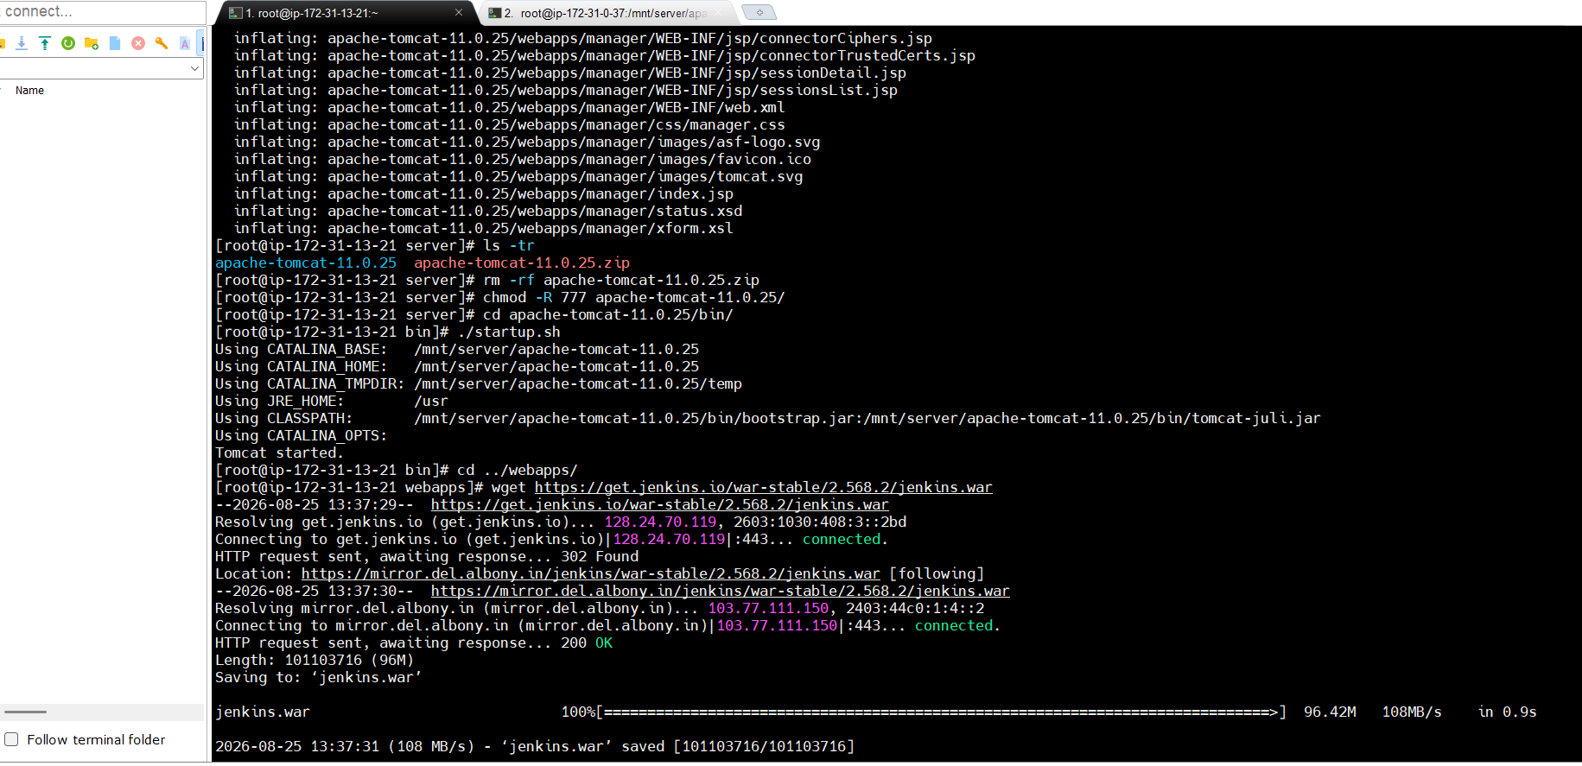
Step 3 open Jenkins dashboard and add goto manage Jenkins then click on tool and add maven
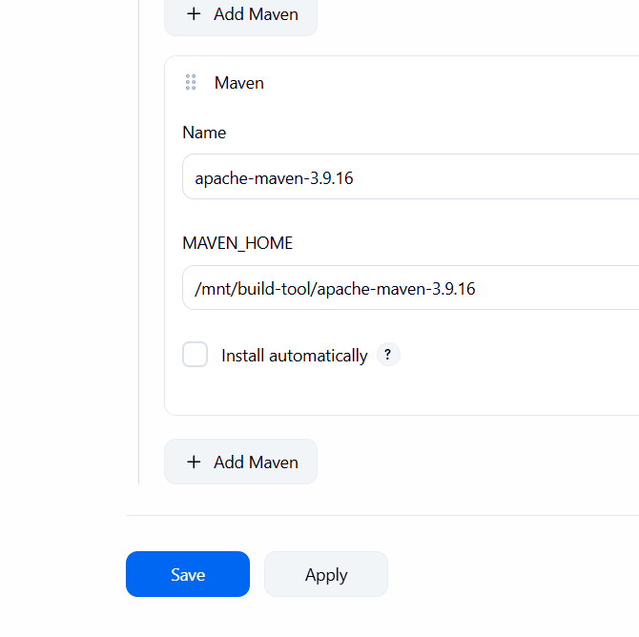
Step 4 – lauch 2nd instance and add java , tomcat and give permission to tomcat then goto bin and start ./statup.sh and then create 1 remote root directory inside mnt and give 777 permission
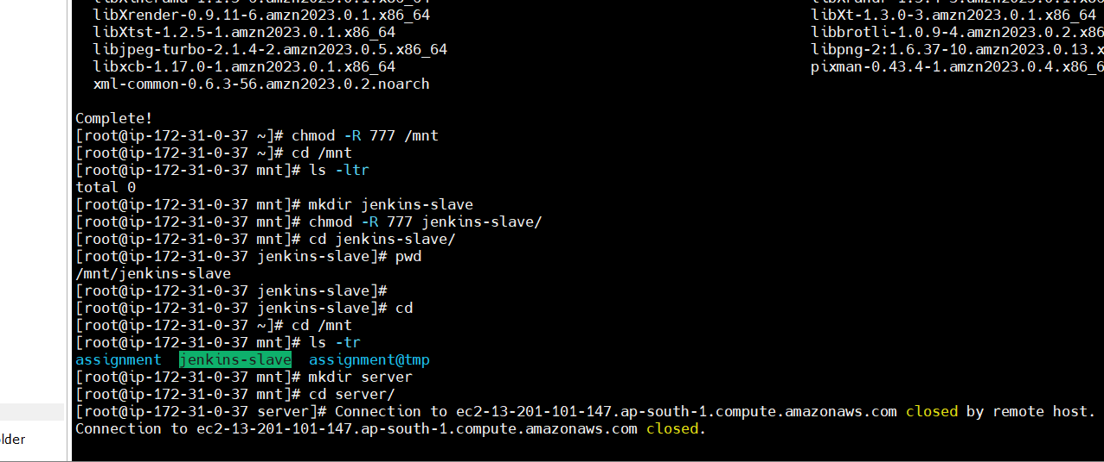
Step 5 – create 1 node goto Jenkins manage and click on add node then set up add host which is private ip of slave-1 instance and then add remote root directory and create credential ssh via private key
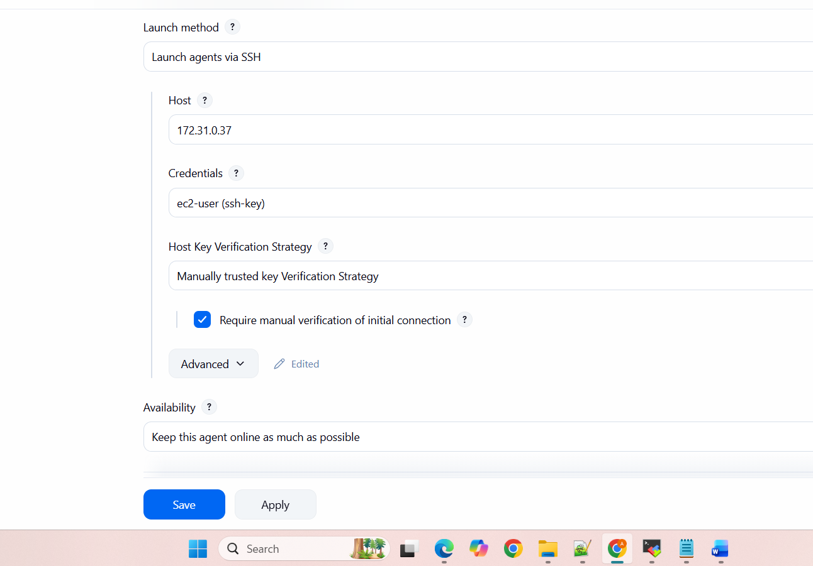
Step 6 – create job and add code
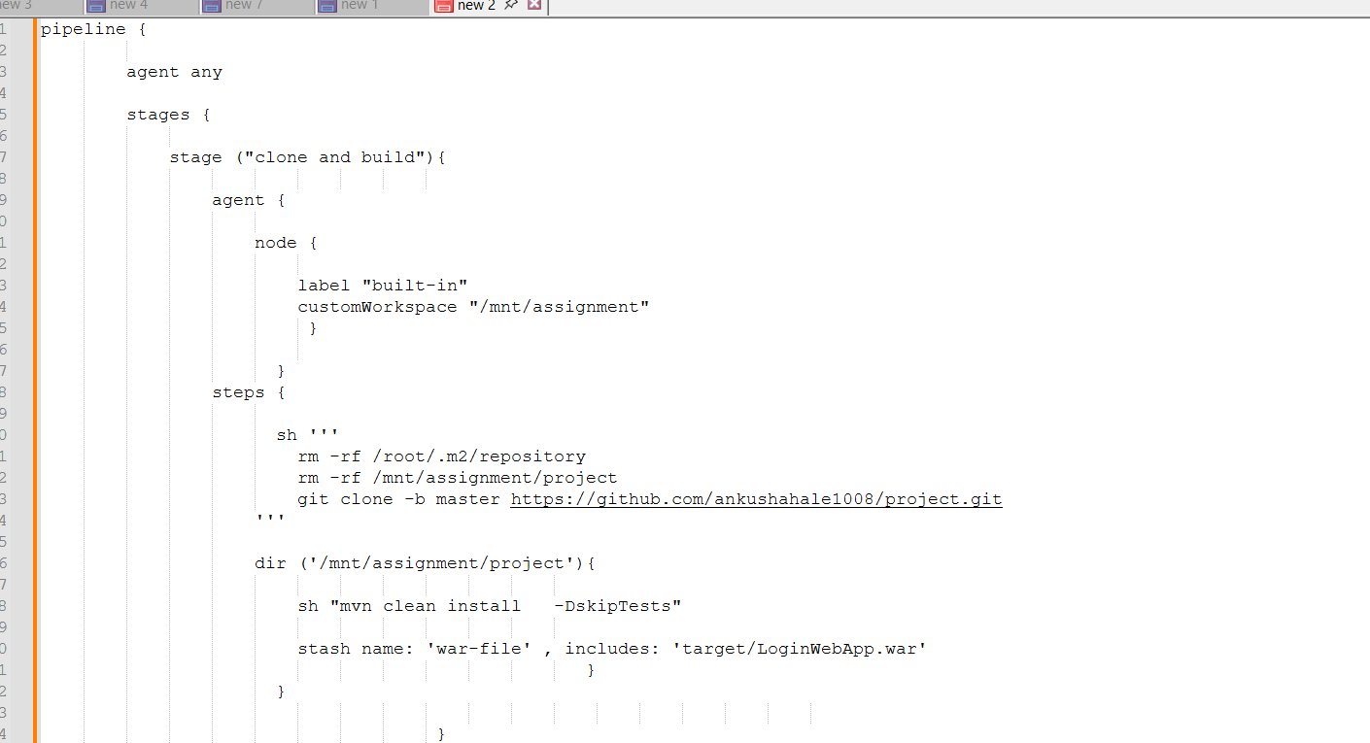
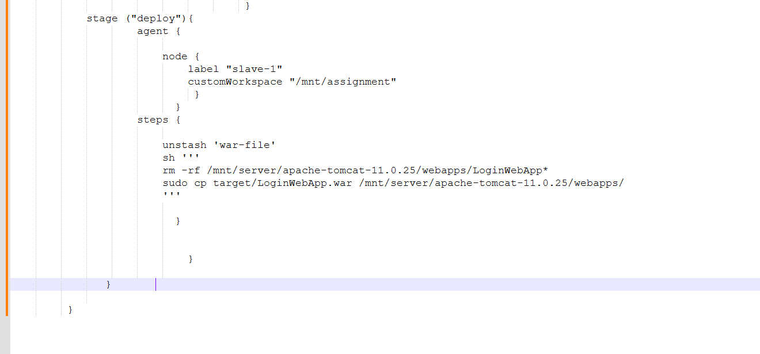
Step 7 – click on apply and save then click on build now then check
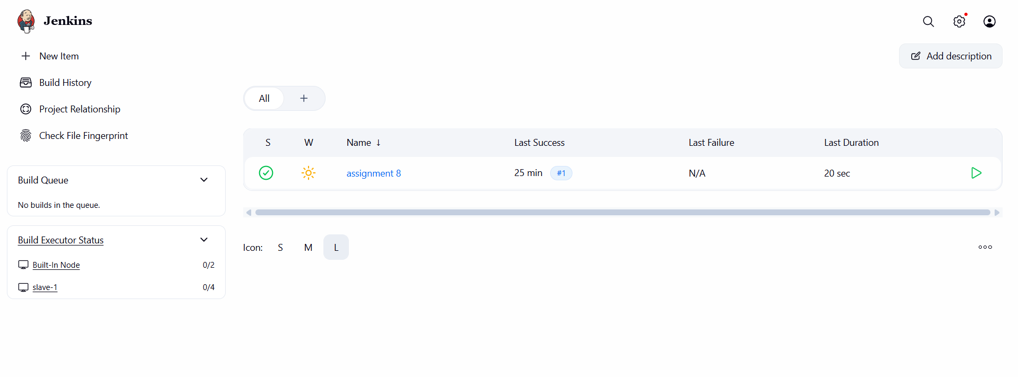
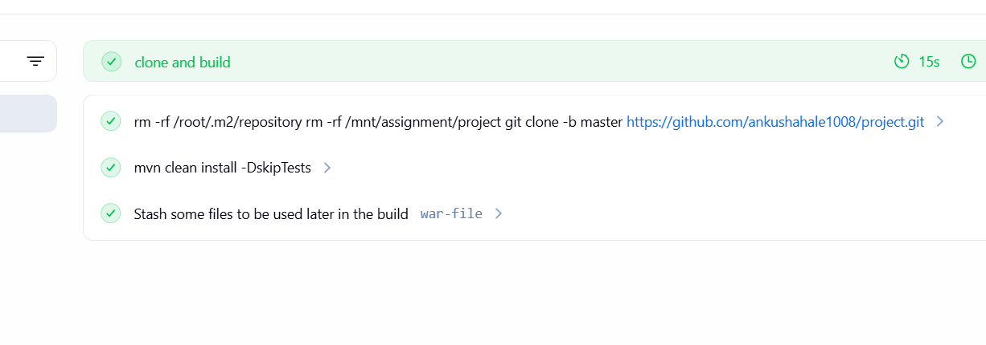
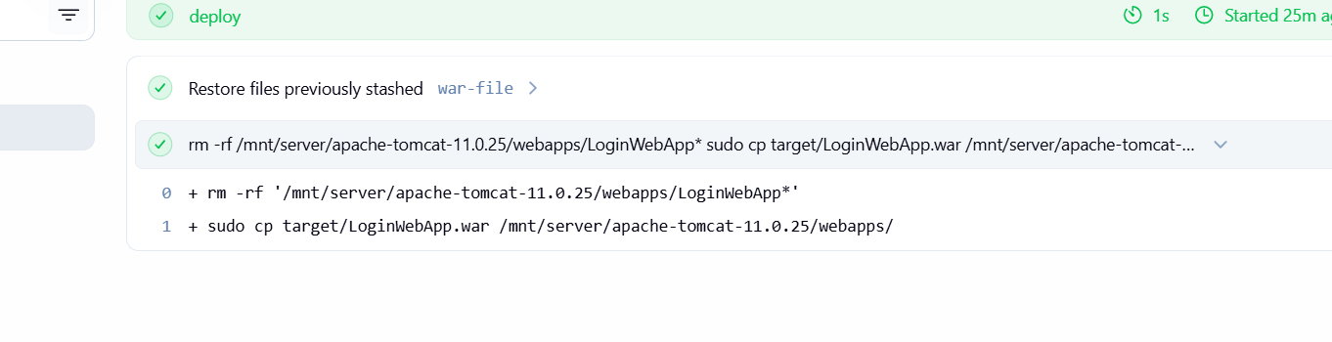
Step 8 – check using slave -1 url like http://slave-1-ip:8080/LoginWebApp
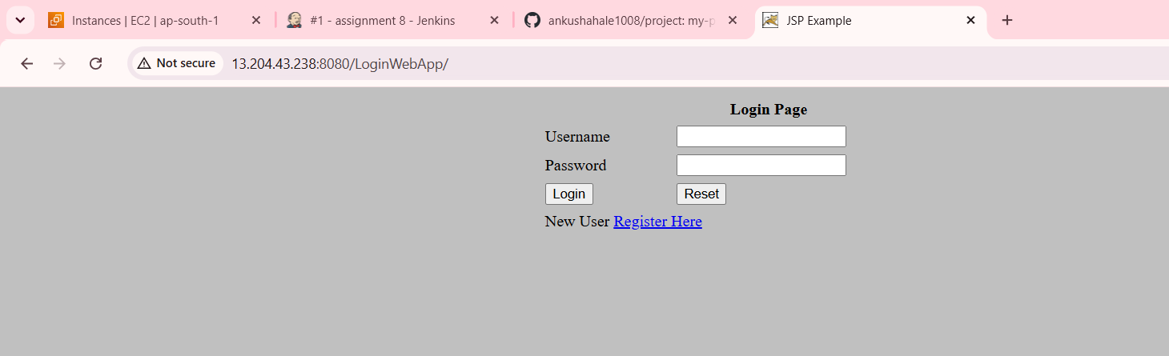
Done Successfully.

